Web Designing Assignment

Term-1

Module (HTML) -1

1. Are the HTML tags and elements the same thing?

--> HTML Tags are building blocks of HTML Page. Tags are used to display content on browser.

--> HTML elements are components that are used in HTML Page. HTML elements consist of start tag.

1. What are tags and attributes in HTML?

--> HTML tags are used to hold the element. element holds the content.

-->attributes are used to describe the characteristic of HTML element in detail.tag starts with < and ends with > Whatever written in a HTML tag are elements.

1. What are void elements in HTML? With Example

--> Void element is an element whose content model never allows it to have contents under any circumstances.

--> Void elements can have attributes.

# Example: area,base,br,col,command,embed,hr,img,input,keygen,link,meta,param,source,track,wbr.

1. What are HTML entities? With Example.

--> Some characters are reserved in HTML.

--> If you use the less than or greater than signs in HTML text, browser mix them with tags.

--> Entity names or numbers are used to display reserved character.

# Example

< = &lt;

> = &gt;

1. What are different types of lists in HTML? With Example.

--> HTML lists allow web developers to group a set of related items in lists.

--> unordered list:

•Car

•Bike

•Cycle

•Plane

--> ordered list:

1.Car

2.Bike

3.Plane

4.Cycle

-->Description List or Definition List

Bike

Super bike

Royal Enfield

Plane

Fighter plane

Commercial plane

Private plane

1. What is the ‘class’ attribute in HTML? With Example.

--> The class attribute specifies one or more class names for an element.

--> it is used to point to a class in a style sheet.

--> It can used in JavaScript to make changes to HTML elements with a specified class.

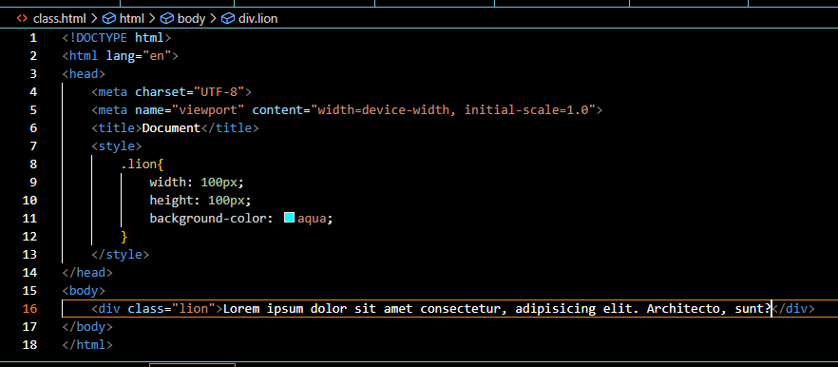

1. What is the difference between the ‘id’ attribute and the ‘class’ attribute of HTML elements? With Example.

--> The difference between Class and ID:

--> Class name can used by multiple HTML elements.

--> ID name must used by one HTML element in the page. .

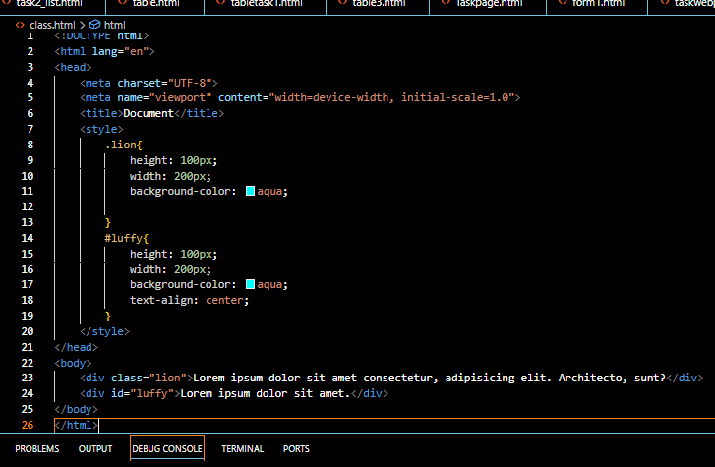

1. What are the various formatting tags in HTML?

--> Formatting elements were designed to display special types of text

# Example :

--> <b> - Bold text

--> <strong> - Important text

--> <i> - Italic text

--> <em> - Emphasized text

--> <mark> - Marked text

--> <small> - Smaller text

--> <del> - Deleted text

--> <ins> - Inserted text

1. How is cell padding different from cell spacing? With Example.

--> Cell padding is used to create a border around the content area of a web page. Cell padding set through CSS.

--> Cell spacing is used for positioning elements in that content area. Cell spacing can only conrolled using HTML5.

1. How can we club two or more rows or columns into a single row or column in an HTML table?

--> For merge two or more table cells in a column using the colspan attribute And to merge two or more row cells, use the rowspan attribute in a <td> tag

1. What is the difference between a block-level element and an inline element?

# Block element

--> Block elements always start from a new line.

--> Block elements cover space all width on webpage.

# Inline element

--> Inline elements never start from a new line.

--> Inline elements only cover the space of content.

1. How to create a Hyperlink in HTML? With Example.

--> HTML links are hyperlinks. You can click on a link and jump to another document.

-->Use the <a> element to define a link.use the href attribute to define the link address.

-->Use the target attribute to define where to open the linked document.use the <img> element to use an image as a link.

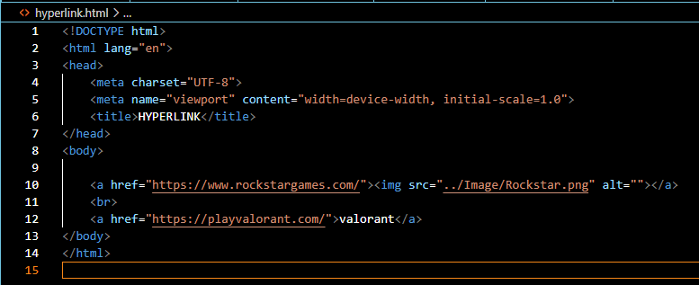

1. What is the use of an iframe tag? With Example.

--> The iframe element is specified with the iframe tag. It can placed anywhere in an HTML document.

--> Iframes is used to embed specific content from one web page like a video, form, document, full web page in a different web page.

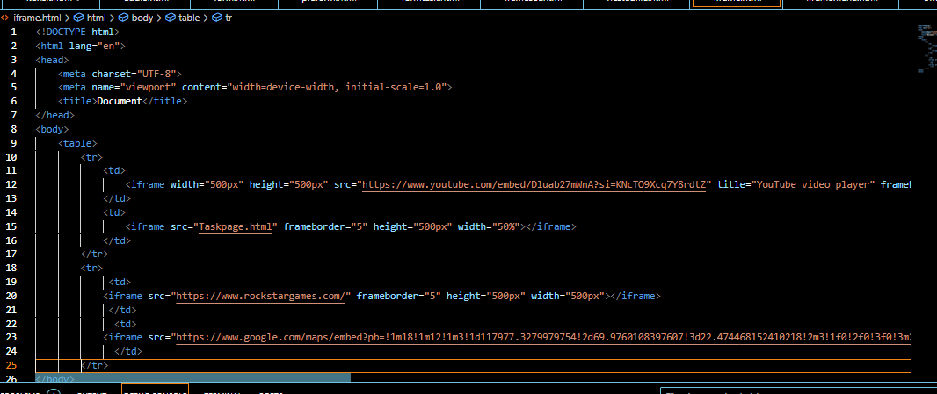

1. What is the use of a span tag? Explain with example.

--> The span tag is a generic inline container element.

--> span tag is only use space which is taken by content.

-->It is similar but not the same as the <div> tag.

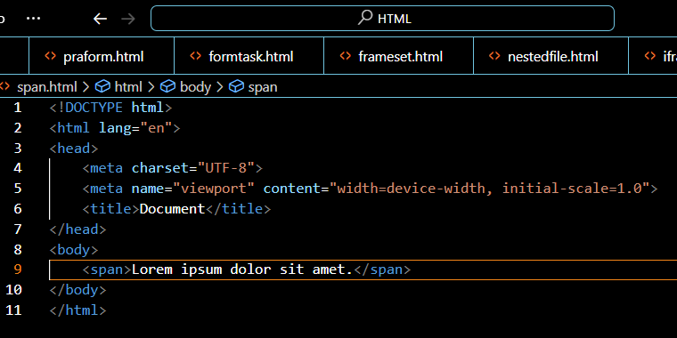

1. How to insert a picture into a background image of a web page? With Example.

--> We can use the background attribute in the body tag to set an image as the background of the webpage.

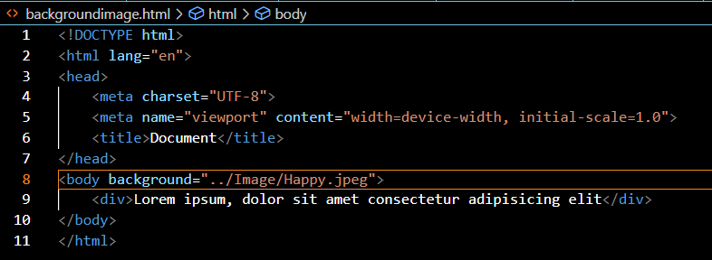

1. How are active links different from normal links?

--> Normal link is just a line of code that contains a pointer to another resource.

--> Active link is that line of code in action, opening that other resource.

1. What are the different tags to separate sections of text?

--> Three tags are there, to separate the texts. usually <br> tag is used to separate line of texts.

--> Other tags are <p> tag and <blockquote> tag.

1. What is SVG?

--> SVG is a language for describing 2D graphics in XML.

--> SVG is an XML-based vector image format for defining 2D-graphics, having support for animation.

1. What is difference between HTML and XHTML?

# XHTML

--> XHTML requires a DTD to be specified, defines the rules for the structure of the document.

--> XHTML is case sensitive, meaning that elements and attributes must be in lower case.

# HTML

--> HTML does not require a DTD.

--> HTML is not case sensitive.

1. What are logical and physical tags in HTML?

# Physical tag

-->These tags are used to provide the visual appearance to the text.

# Logical tag

-->These tags are used to add some logical or semantic value to the text.